UNITED STATES
SECURITIES AND EXCHANGE COMMISSION
WASHINGTON, DC 20549

FORM 8-K

CURRENT REPORT
PURSUANT TO SECTION 13 OR 15(d)
OF THE SECURITIES EXCHANGE ACT OF 1934
Date of Report (Date of earliest event reported): August 6, 2026


i3 Verticals, Inc.
(Exact name of registrant as specified in its charter)

Delaware |  |  |  |  |  | 001-38532 |  |  |  |  |  | 82-4052852
(State or Other Jurisdiction  of Incorporation) |  |  |  |  |  | (Commission  File Number) |  |  |  |  |  | (I.R.S. Employer  Identification No.)
40 Burton Hills Blvd., Suite 415  Nashville, TN |  |  |  |  |  |  |  |  |  |  |  | 37215
(Address of principal executive offices) |  |  |  |  |  |  |  |  |  |  |  | (Zip Code)
(615) 465-4487
(Registrant’s telephone number, including area code)

Not Applicable
(Former name or former address, if changed since last report)

Check the appropriate box if the Form 8-K filing is intended to simultaneously satisfy the filing obligation of the registrant under any of the following provisions (see General Instruction A.2. below):

☐ |  |  | Written communications pursuant to Rule 425 under the Securities Act (17 CFR 230.425)
☐ |  |  | Soliciting material pursuant to Rule 14a-12 under the Exchange Act (17 CFR 240.14a-12)
☐ |  |  | Pre-commencement communications pursuant to Rule 14d-2(b) under the Exchange Act (17 CFR 240.14d- 2(b))
☐ |  |  | Pre-commencement communications pursuant to Rule 13e-4(c) under the Exchange Act (17 CFR 240.13e- 4(c))
Securities registered pursuant to Section 12(b) of the Act:
Title of each class |  |  | Trading Symbol(s) |  |  | Name of each exchange on which registered
Class A Common Stock, $0.0001 Par Value |  |  | IIIV |  |  | Nasdaq Global Select Market
Indicate by check mark whether the registrant is an emerging growth company as defined in Rule 405 of the Securities Act of 1933 (§230.405 of this chapter) or Rule 12b-2 of the Securities Exchange Act of 1934 (§240.12b-2 of this chapter).
Emerging growth company. ☐

If an emerging growth company, indicate by check mark if the registrant has elected not to use the extended transition period for complying with any new or revised financial accounting standards provided pursuant to Section 13(a) of the Exchange Act. ☐

As provided in General Instruction B.2 of Form 8-K, the information contained in Item 2.02 and 7.01 of this Current Report on Form 8-K (including Exhibits 99.1 and 99.2 hereto) shall not be deemed to be “filed” for purposes of Section 18 of the Securities Exchange Act of 1934, as amended, nor shall such information be deemed to be incorporated by reference in any filing under the Securities Act of 1933, as amended, except as shall be expressly set forth by specific reference in such a filing.
Item 2.02. Results of Operations and Financial Condition.
On August 6, 2026, i3 Verticals, Inc. (the “Company”) issued a press release announcing the results of its operations for the three and nine months ended June 30, 2026. A copy of the press release is furnished as Exhibit 99.1 hereto and is hereby incorporated by reference into this Item 2.02.
Item 7.01. Regulation FD Disclosure.

The Company has also prepared a supplemental presentation (the “Supplemental Presentation”) providing certain supplemental financial information for the three months ended June 30, 2026. A copy of the Supplemental Presentation is furnished as Exhibit 99.2 hereto and is hereby incorporated by reference into this Item 7.01. A copy of the Supplemental Presentation is also available on the Investors section of the Company’s website, www.i3verticals.com.
Item 9.01. Financial Statements and Exhibits.

(d) Exhibits:
Exhibit No. |  |  |  |  |  | Description
99.1 |  |  |  |  |  | Press release issued by i3 Verticals, Inc. on August 6, 2026
99.2 |  |  |  |  |  | Supplemental Presentation
104 |  |  |  |  |  | Cover Page Interactive Data File (embedded within the Inline XBRL document).

SIGNATURES
Pursuant to the requirements of the Securities Exchange Act of 1934, the registrant has duly caused this report to be signed on its behalf by the undersigned hereunto duly authorized.
Date: August 6, 2026

i3 VERTICALS, INC.
By: |  |  |  |  |  | /s/ Geoff Smith
Name: |  |  |  |  |  | Geoff Smith
Title: |  |  |  |  |  | Chief Financial Officer
 |  |  |  |  |  | (Principal Financial Officer and Principal Accounting Officer)



i3 VERTICALS REPORTS THIRD QUARTER 2026 FINANCIAL RESULTS
NASHVILLE, Tenn. (August 6, 2026) – i3 Verticals, Inc. (Nasdaq: IIIV) (“i3 Verticals” or the “Company”) today reported its financial results for the fiscal third quarter ended June 30, 2026.
Highlights from continuing operations1 for the three and nine months ended June 30, 2026 vs. 2025
•Third quarter revenue from continuing operations1 was $53.1 million, an increase of 2.2% over the prior year's third quarter. Revenue from continuing operations1 for the nine months ended June 30, 2026, was $163.3 million, an increase of 3.2% over the prior year's first nine months.
•Third quarter net income from continuing operations1 was $5.9 million, compared to net loss from continuing operations1 of $1.0 million for the prior year's third quarter. Net income from continuing operations1 for the nine months ended June 30, 2026, was $9.2 million, compared to net income from continuing operations1 of $4.1 million in the prior year's first nine months.
•Third quarter net income from continuing operations attributable to i3 Verticals, Inc.1 was $3.6 million, compared to net loss from continuing operations attributable to i3 Verticals, Inc.1 of $0.4 million in the prior year's third quarter. Net income from continuing operations attributable to i3 Verticals, Inc.1 for the nine months ended June 30, 2026, was $5.7 million, compared to net income from continuing operations attributable to i3 Verticals, Inc.1 of $2.5 million in the prior year's first nine months.
•Third quarter adjusted EBITDA from continuing operations1,2 was $13.3 million, an increase of 4.6% over the prior year's third quarter. Adjusted EBITDA from continuing operations1,2 for the nine months ended June 30, 2026, was $43.5 million, an increase of 0.9% over the prior year's first nine months.
•Third quarter adjusted EBITDA from continuing operations1,2 as a percentage of revenue was 25.1%, compared to 24.5% in the prior year's third quarter. Adjusted EBITDA from continuing operations1,2 as a percentage of revenue for the nine months ended June 30, 2026, was 26.7%, compared to 27.3% in the prior year's first nine months.
•Diluted net income per share attributable to Class A common stockholders from continuing operations1,3 was $0.19, compared to diluted net loss per share attributable to Class A common stockholders from continuing operations1,3 of $0.03 in the prior year's third quarter. Diluted net income per share attributable to Class A common stockholders from continuing operations1,3 was $0.25 in the nine months ended June 30, 2026, compared to diluted net income per share attributable to Class A common stockholders from continuing operations1,3 of $0.10 in the prior year's first nine months.
•Third quarter adjusted diluted earnings per share from continuing operations1,2,3, which gives effect to the Company's 25% estimated long-term effective tax rate4, was $0.25 compared to $0.23 for the prior year's third quarter. Non-GAAP adjusted diluted earnings per share from continuing operations1,2,3 for the nine months ended June 30, 2026, was $0.82 compared to $0.78 for the prior year's first nine months.
•Annualized Recurring Revenue ("ARR") from continuing operations1,5 for the three months ended June 30, 2026 and 2025 was $174.1 million and $160.8 million, respectively, representing a period-to-period growth rate of 8.3%.

See footnotes on the following page.
IIIV Reports Third Quarter 2026 Financial Results
-MORE-
Page 2
August 6, 2026
1.As a result of the sale of the Company’s merchant services business (the "Merchant Services Business"), which was completed on September 20, 2024, and the sale of the Company's healthcare revenue cycle management business (the "Healthcare RCM Business"), which was completed on May 5, 2025, the historical results of the Merchant Services Business and the Healthcare RCM Business have been reflected in discontinued operations in the consolidated statement of operations included in this earnings release, and continuing operations reflect the Company's remaining operations after giving effect to such classifications. Prior period results have been recast to reflect this presentation.
2.Represents a non-GAAP financial measure. For additional information regarding non-GAAP financial measures (including reconciliation information), see the attached schedules to this release.
3.Diluted net income (loss) per share attributable to Class A common stockholders from continuing operations and adjusted diluted earnings per share from continuing operations both exclude discontinued operations of the Merchant Services Business and the Healthcare RCM Business but include the consolidated cash interest expense.
4.Corporate income tax expense is based on non-GAAP adjusted income before taxes from continuing operations and is calculated using a tax rate of 25.0% for both the nine months ended June 30, 2026 and 2025, based on the estimated long-term effective tax rate, considering blended federal and state tax rates.
5.Annualized Recurring Revenue (ARR) is the annualized revenue derived from recurring sources where the Company has an ongoing contract with its customers. The Company believes revenue from recurring sources is a strategic priority. ARR is comprised of software-as-a-service (“SaaS”) arrangements, transaction-based software-revenue, software maintenance, recurring software-based services, payments revenue and other recurring revenue sources within the quarter. The sum of these revenue categories is multiplied by four to calculate ARR. ARR excludes revenue that is not recurring or is one-time in nature. The Company's management believes this metric provides useful information to investors by providing visibility regarding the ongoing revenue potential of the Company's business model and providing a clearer picture of its sustainable revenue base. Further, the Company's management uses ARR as a metric because it helps to assess the health and trajectory of the Company's business. The Company's management believes that focusing on ARR can orient the Company's sales and operations management towards long-term, reliable revenue growth. This focus on recurring revenue is particularly relevant for businesses operating under a subscription model, where customer retention and contract renewals play a significant role in long-term financial performance. ARR does not have a standardized definition and is therefore unlikely to be comparable to similarly titled measures presented by other companies. It should be reviewed independently of revenue, and it is not a forecast. Additionally, ARR does not take into account seasonality. The active contracts at the end of a reporting period used in calculating ARR may or may not be extended or renewed by the Company's customers.

IIIV Reports Third Quarter Fiscal Year 2026 Financial Results
-MORE-
Page 3
August 6, 2026
Greg Daily, Chairman and CEO of i3 Verticals, commented, "Our third quarter results came in below our expectations, reflecting ongoing weakness in certain non-recurring revenue streams and implementation delays. While we are disappointed with this outcome, we remain focused on attractive future growth opportunities.
“Annualized recurring revenue grew 8% year over year. We are pleased to announce the go-live of four material statewide services in our Transportation market, which we believe will help re-accelerate recurring revenue growth going forward.
"We have now repurchased more than 20% of our outstanding shares under share repurchase programs since October 2024, reflecting our long-term confidence in the direction of our business."
2026 Outlook
The Company's practice is to provide annual guidance, excluding the impact of future acquisitions and transaction-related costs.
The Company is providing the following revised outlook for the fiscal year ending September 30, 2026:

(in thousands, except share and per share amounts) |  |  | Previous Outlook Range |  |  |  |  |  |  |  |  |  |  |  | Revised Outlook Range
 |  |  | Fiscal year ending September 30, 2026
Revenue |  |  | $ | 221,000 |  | - |  |  | $ | 229,000 |  |  |  |  | $ | 216,000 |  | - |  |  | $ | 221,000
Adjusted EBITDA (non-GAAP) |  |  | $ | 61,000 |  | - |  |  | $ | 65,000 |  |  |  |  | $ | 57,000 |  | - |  |  | $ | 60,000
Adjusted diluted earnings per share(1) (non-GAAP) |  |  | $ | 1.09 |  | - |  |  | $ | 1.15 |  |  |  |  | $ | 1.08 |  | - |  |  | $ | 1.12
_______________________
1.Assumes an effective tax rate of 25.0% (non-GAAP), based on the estimated long-term effective tax rate, considering blended federal and state tax rates.
With respect to the “2026 Outlook” above, reconciliations of adjusted EBITDA from continuing operations and adjusted diluted earnings per share from continuing operations guidance to the closest corresponding GAAP measure on a forward-looking basis are not available without unreasonable efforts. This inability results from the inherent difficulty in forecasting generally and quantifying certain projected amounts that are necessary for such reconciliations. In particular, sufficient information is not available to calculate certain adjustments required for such reconciliations, including changes in the fair value of contingent consideration, income tax expense of i3 Verticals, Inc. and equity-based compensation expense. The Company expects these adjustments may have a potentially significant impact on future GAAP financial results.
Conference Call
The Company will host a conference call on Friday, August 7, 2026, at 8:30 a.m. ET, to discuss financial results and operations. To listen to the call live via telephone, participants should dial (844) 887-9399 approximately 10 minutes prior to the start of the call. A telephonic replay will be available from 11:30 a.m. ET on August 7, 2026, through August 14, 2026, by dialing (855) 669-9658 and entering Confirmation Code 9466422.
To listen to the call live via webcast, participants should visit the “Investors” section of the Company’s website, www.i3verticals.com, and go to the “Events” page approximately 10 minutes prior to the start of the call. The online replay will be available on this page of the Company’s website beginning shortly after the conclusion of the call and will remain available for 30 days.
Non-GAAP Measures
This press release contains information prepared in conformity with GAAP as well as non-GAAP information. It is management’s intent to provide non-GAAP financial information to enhance understanding of the Company's consolidated financial information as prepared in accordance with GAAP. This non-GAAP information should be considered by the reader in addition to, but not instead of, the financial statements prepared in accordance with GAAP. Each non-GAAP financial measure and the most directly comparable GAAP financial measure are presented for historical periods so as not to imply that more emphasis should be placed on the non-GAAP measure. The non-GAAP financial information presented may be determined or calculated differently by other companies.

IIIV Reports Third Quarter Fiscal Year 2026 Financial Results
-MORE-
Page 4
August 6, 2026
Additional information about non-GAAP financial measures, and a reconciliation of those measures to the most directly comparable GAAP measures, is included in the financial schedules of this release.
About i3 Verticals
The Company provides mission-critical enterprise software solutions to public sector entities. These comprehensive cloud-native solutions address a broad range of government functions, including courts and public safety, public administration, utilities, transportation and schools. The Company’s mission is to enable state and local governments and related agencies to perform their functions and serve their constituents as effectively and efficiently as possible. With thousands of software installations across all 50 states and Canada, i3 Verticals is a leader in the public sector vertical. More information about the Company can be found at www.i3verticals.com.
Forward-Looking Statements
This release contains forward-looking statements that are subject to risks and uncertainties. All statements other than statements of historical fact or relating to present facts or current conditions included in this release are forward-looking statements, including any statements regarding the Company's fiscal 2026 financial outlook for continuing operations and statements of a general economic or industry specific nature. Forward-looking statements give the Company's current expectations and projections relating to its financial condition, results of operations, guidance, plans, objectives, future performance and business. You can identify forward-looking statements by the fact that they do not relate strictly to historical or current facts. These statements may include words such as “anticipate,” “estimate,” “expect,” “project,” “plan,” “intend,” “believe,” “may,” “will,” “should,” “could have,” “exceed,” “significantly,” “likely” and other words and terms of similar meaning in connection with any discussion of the timing or nature of future operating or financial performance or other events.
The forward-looking statements contained in this release are based on assumptions that we have made in light of the Company's industry experience and its perceptions of historical trends, current conditions, expected future developments and other factors we believe are appropriate under the circumstances. As you review and consider information presented herein, you should understand that these statements are not guarantees of future performance or results. They depend upon future events and are subject to risks, uncertainties (many of which are beyond the Company's control) and assumptions. Factors that could cause actual results to differ from those expressed or implied by our forward-looking statements include, among other things: ongoing and future economic and geopolitical conditions, including the impact of inflation, elevated interest rates, tariff and trade-related developments, ongoing military conflicts in the Middle East and Ukraine, the evolving legal, ethical, regulatory and operational landscape related to artificial intelligence technologies, competition in our industry and our ability to compete effectively, regulatory developments, the successful integration of acquired businesses, our ability to execute on our strategy and achieve our goals following the completion of the sale of our Merchant Services Business and Healthcare RCM Business, and future decisions made by us and our competitors. All of these factors are difficult or impossible to predict accurately and many of them are beyond our control. For a further list and description of these and other important risks and uncertainties that may affect our future operations, see Part I, Item 1A - Risk Factors in our most recent Annual Report on Form 10-K filed with the Securities and Exchange Commission, which we may further update in Part II, Item 1A - Risk Factors in Quarterly Reports on Form 10-Q we will file hereafter, and the risks and uncertainties identified in other filings filed with the Securities and Exchange Commission from time to time.
Any forward-looking statement made by us in this release speaks only as of the date of this release and we undertake no obligation to publicly update any forward-looking statement, whether as a result of new information, future developments or otherwise, except as may be required by law.
Contact:
Clay Whitson
Chief Strategy Officer
(888) 251-0987
investorrelations@i3verticals.com

IIIV Reports Third Quarter Fiscal Year 2026 Financial Results
-MORE-
Page 5
August 6, 2026
i3 Verticals, Inc. Consolidated Statements of Operations
(Unaudited)
($ in thousands, except share and per share amounts)
 |  |  | Three Months Ended June 30, |  |  |  |  |  |  |  |  |  |  |  |  |  |  |  |  |  | Nine Months Ended June 30,
 |  |  | 2026 |  |  |  |  |  | 2025 |  |  |  |  |  | % Change |  |  |  |  |  | 2026 |  |  |  |  |  | 2025 |  |  |  |  |  | % Change
Revenue |  |  | $ | 53,067 |  |  |  |  | $ | 51,901 |  |  |  |  | 2% |  |  |  |  |  | $ | 163,256 |  |  |  |  | $ | 158,257 |  |  |  |  | 3%
Operating expenses
Costs of services (excluding depreciation and amortization) |  |  | 16,314 |  |  |  |  |  | 16,733 |  |  |  |  |  | (3)% |  |  |  |  |  | 51,034 |  |  |  |  |  | 48,889 |  |  |  |  |  | 4%
Selling, general and administrative |  |  | 28,858 |  |  |  |  |  | 33,018 |  |  |  |  |  | (13)% |  |  |  |  |  | 84,905 |  |  |  |  |  | 85,779 |  |  |  |  |  | (1)%
Depreciation and amortization |  |  | 7,349 |  |  |  |  |  | 6,989 |  |  |  |  |  | 5% |  |  |  |  |  | 21,917 |  |  |  |  |  | 20,848 |  |  |  |  |  | 5%
Change in fair value of contingent consideration |  |  | 1,438 |  |  |  |  |  | (26) |  |  |  |  |  | n/m |  |  |  |  |  | 940 |  |  |  |  |  | 440 |  |  |  |  |  | 114%
Total operating expenses |  |  | 53,959 |  |  |  |  |  | 56,714 |  |  |  |  |  | (5)% |  |  |  |  |  | 158,796 |  |  |  |  |  | 155,956 |  |  |  |  |  | 2%
(Loss) income from operations |  |  | (892) |  |  |  |  |  | (4,813) |  |  |  |  |  | (81)% |  |  |  |  |  | 4,460 |  |  |  |  |  | 2,301 |  |  |  |  |  | 94%
Other expenses (income)
Interest expense |  |  | 1,820 |  |  |  |  |  | 806 |  |  |  |  |  | 126% |  |  |  |  |  | 3,342 |  |  |  |  |  | 1,932 |  |  |  |  |  | 73%
Other income |  |  | (9,903) |  |  |  |  |  | (4,601) |  |  |  |  |  | 115% |  |  |  |  |  | (10,534) |  |  |  |  |  | (7,020) |  |  |  |  |  | 50%
Total other income |  |  | (8,083) |  |  |  |  |  | (3,795) |  |  |  |  |  | 113% |  |  |  |  |  | (7,192) |  |  |  |  |  | (5,088) |  |  |  |  |  | 41%
Income (loss) before income taxes |  |  | 7,191 |  |  |  |  |  | (1,018) |  |  |  |  |  | n/m |  |  |  |  |  | 11,652 |  |  |  |  |  | 7,389 |  |  |  |  |  | 58%
Provision for (benefit from) income taxes |  |  | 1,313 |  |  |  |  |  | (22) |  |  |  |  |  | n/m |  |  |  |  |  | 2,495 |  |  |  |  |  | 3,272 |  |  |  |  |  | (24)%
Net income (loss) from continuing operations |  |  | 5,878 |  |  |  |  |  | (996) |  |  |  |  |  |  |  |  |  |  |  | 9,157 |  |  |  |  |  | 4,117
Net (loss) income from discontinued operations, net of income taxes |  |  | (217) |  |  |  |  |  | 19,421 |  |  |  |  |  |  |  |  |  |  |  | (355) |  |  |  |  |  | 18,185
Net income |  |  | 5,661 |  |  |  |  |  | 18,425 |  |  |  |  |  | (69)% |  |  |  |  |  | 8,802 |  |  |  |  |  | 22,302 |  |  |  |  |  | (61)%
Net income (loss) from continuing operations attributable to non-controlling interest |  |  | 2,258 |  |  |  |  |  | (586) |  |  |  |  |  |  |  |  |  |  |  | 3,497 |  |  |  |  |  | 1,653
Net (loss) income from discontinued operations attributable to non-controlling interest |  |  | (79) |  |  |  |  |  | 6,129 |  |  |  |  |  |  |  |  |  |  |  | (125) |  |  |  |  |  | 5,865
Net income attributable to non-controlling interest |  |  | 2,179 |  |  |  |  |  | 5,543 |  |  |  |  |  | (61)% |  |  |  |  |  | 3,372 |  |  |  |  |  | 7,518 |  |  |  |  |  | (55)%
Net income (loss) from continuing operations attributable to i3 Verticals, Inc. |  |  | 3,620 |  |  |  |  |  | (410) |  |  |  |  |  |  |  |  |  |  |  | 5,660 |  |  |  |  |  | 2,464
Net (loss) income from discontinued operations attributable to i3 Verticals, Inc. |  |  | (138) |  |  |  |  |  | 13,292 |  |  |  |  |  |  |  |  |  |  |  | (230) |  |  |  |  |  | 12,320
Net income attributable to i3 Verticals, Inc. |  |  | $ | 3,482 |  |  |  |  | $ | 12,882 |  |  |  |  | (73)% |  |  |  |  |  | $ | 5,430 |  |  |  |  | $ | 14,784 |  |  |  |  | (63)%
Net income (loss) per share attributable to Class A common stockholders from continuing operations:
Basic |  |  | $ | 0.19 |  |  |  |  | $ | (0.02) |  |  |  |  |  |  |  |  |  |  | $ | 0.26 |  |  |  |  | $ | 0.10
Diluted |  |  | $ | 0.19 |  |  |  |  | $ | (0.03) |  |  |  |  |  |  |  |  |  |  | $ | 0.25 |  |  |  |  | $ | 0.10
Net (loss) income per share attributable to Class A common stockholders from discontinued operations:
Basic |  |  | $ | (0.01) |  |  |  |  | $ | 0.55 |  |  |  |  |  |  |  |  |  |  | $ | (0.01) |  |  |  |  | $ | 0.52
Diluted |  |  | $ | (0.01) |  |  |  |  | $ | 0.55 |  |  |  |  |  |  |  |  |  |  | $ | (0.01) |  |  |  |  | $ | 0.49
Weighted average shares of Class A common stock outstanding:
Basic, for continuing operations |  |  | 19,419,792 |  |  |  |  |  | 24,345,826 |  |  |  |  |  |  |  |  |  |  |  | 21,638,108 |  |  |  |  |  | 23,909,714
Diluted, for continuing operations |  |  | 19,543,611 |  |  |  |  |  | 32,983,325 |  |  |  |  |  |  |  |  |  |  |  | 22,285,629 |  |  |  |  |  | 24,823,635
Basic, for discontinued operations |  |  | 19,419,792 |  |  |  |  |  | 24,345,826 |  |  |  |  |  |  |  |  |  |  |  | 21,638,108 |  |  |  |  |  | 23,909,714
Diluted, for discontinued operations |  |  | 27,801,473 |  |  |  |  |  | 24,345,826 |  |  |  |  |  |  |  |  |  |  |  | 30,019,789 |  |  |  |  |  | 34,183,267
n/m = not meaningful

IIIV Reports Third Quarter Fiscal Year 2026 Financial Results
-MORE-
Page 6
August 6, 2026
i3 Verticals, Inc. Consolidated Balance Sheets
(Unaudited)
($ in thousands, except share and per share amounts)
 |  |  | June 30, |  |  |  |  |  | September 30,
 |  |  | 2026 |  |  |  |  |  | 2025
Assets
Current assets
Cash and cash equivalents |  |  | $ | 2,647 |  |  |  |  | $ | 66,672
Accounts receivable, net |  |  | 48,519 |  |  |  |  |  | 58,467
Settlement assets |  |  | 36 |  |  |  |  |  | 411
Prepaid expenses and other current assets |  |  | 12,270 |  |  |  |  |  | 12,075
Total current assets |  |  | 63,472 |  |  |  |  |  | 137,625
Property and equipment, net |  |  | 6,627 |  |  |  |  |  | 7,181
Restricted cash |  |  | 2,760 |  |  |  |  |  | 250
Capitalized software, net |  |  | 50,983 |  |  |  |  |  | 48,314
Goodwill |  |  | 282,284 |  |  |  |  |  | 248,469
Intangible assets, net |  |  | 153,599 |  |  |  |  |  | 135,797
Deferred tax asset |  |  | 46,595 |  |  |  |  |  | 49,058
Operating lease right-of-use assets |  |  | 4,495 |  |  |  |  |  | 4,577
Other assets |  |  | 16,169 |  |  |  |  |  | 7,140
Total assets |  |  | $ | 626,984 |  |  |  |  | $ | 638,411
Liabilities and equity
Liabilities
Current liabilities
Accounts payable |  |  | $ | 4,384 |  |  |  |  | $ | 6,248
Accrued expenses and other current liabilities |  |  | 21,026 |  |  |  |  |  | 24,525
Settlement obligations |  |  | 36 |  |  |  |  |  | 411
Deferred revenue |  |  | 25,285 |  |  |  |  |  | 37,678
Current portion of operating lease liabilities |  |  | 1,907 |  |  |  |  |  | 1,827
Total current liabilities |  |  | 52,638 |  |  |  |  |  | 70,689
Long-term debt, less current portion |  |  | 114,276 |  |  |  |  |  | —
Long-term tax receivable agreement obligations |  |  | 32,192 |  |  |  |  |  | 32,191
Operating lease liabilities, less current portion |  |  | 2,689 |  |  |  |  |  | 2,964
Other long-term liabilities |  |  | 24,859 |  |  |  |  |  | 14,844
Total liabilities |  |  | 226,654 |  |  |  |  |  | 120,688
Commitments and contingencies
Stockholders' equity
Preferred stock, par value $0.0001 per share, 10,000,000 shares authorized; 0 shares issued and outstanding as of both June 30, 2026 and September 30, 2025 |  |  | — |  |  |  |  |  | —
Class A common stock, par value $0.0001 per share, 150,000,000 shares authorized; 18,241,855 and 23,983,125 shares issued and outstanding as of June 30, 2026 and September 30, 2025, respectively |  |  | 2 |  |  |  |  |  | 2
Class B common stock, par value $0.0001 per share, 40,000,000 shares authorized; 8,381,681 shares issued and outstanding as of both June 30, 2026 and September 30, 2025 |  |  | 1 |  |  |  |  |  | 1
Additional paid-in capital |  |  | 156,844 |  |  |  |  |  | 271,310
Accumulated earnings |  |  | 123,700 |  |  |  |  |  | 118,270
Total stockholders' equity |  |  | 280,547 |  |  |  |  |  | 389,583
Non-controlling interest |  |  | 119,783 |  |  |  |  |  | 128,140
Total equity |  |  | 400,330 |  |  |  |  |  | 517,723
Total liabilities and equity |  |  | $ | 626,984 |  |  |  |  | $ | 638,411

IIIV Reports Third Quarter Fiscal Year 2026 Financial Results
-MORE-
Page 7
August 6, 2026
i3 Verticals, Inc. Consolidated Cash Flow Data
(Unaudited)
($ in thousands)
 |  |  | Nine Months Ended June 30,
 |  |  | 2026 |  |  |  |  |  | 2025
Net cash provided by (used in) operating activities |  |  | $ | 38,414 |  |  |  |  | $ | (8,276)
Net cash (used in) provided by investing activities |  |  | $ | (68,120) |  |  |  |  | $ | 78,774
Net cash used in financing activities |  |  | $ | (32,184) |  |  |  |  | $ | (104,283)

Reconciliation of GAAP to Non-GAAP Financial Measures
The Company discloses the following non-GAAP financial measures in this earnings release:
•Adjusted Income Before Taxes from Continuing Operations. Adjusted income before taxes from continuing operations equals net income (loss) from continuing operations attributable to i3 Verticals Inc., adjusted to add back net income (loss) from continuing operations attributable to non-controlling interest and to exclude certain items on a pre-tax basis which the Company believes may not fully reflect our underlying operating performance. The Company believes that this non-GAAP measure provides useful information to investors in understanding and evaluating the Company’s results of continuing operations and ongoing operational performance on a pre-tax basis.
•Adjusted Net Income from Continuing Operations and Adjusted Diluted Earnings per Share from Continuing Operations. Adjusted net income from continuing operations equals adjusted income before taxes from continuing operations as described above, adjusted to give effect to an effective tax rate of 25%, which reflects our estimated long-term effective tax rate, considering blended federal and state tax rates. Adjusted diluted earnings per share from continuing operations equals adjusted net income from continuing operations divided by our adjusted weighted average shares of adjusted diluted Class A common stock outstanding. The Company believes that these non-GAAP measures provide useful information to investors in understanding and evaluating the Company’s results of continuing operations and ongoing operational performance on a post-tax basis after giving effect to this assumed tax rate. Adjusted Diluted Earnings per Share from Continuing Operations has also been utilized as a metric in connection with performance-based equity awards previously granted by the Company to executives.
•Adjusted EBITDA from Continuing Operations and Adjusted EBITDA Margin from Continuing Operations. Adjusted EBITDA from continuing operations equals net income (loss) from continuing operations attributable to i3 Verticals Inc., before interest, income taxes, depreciation and amortization, adjusted to add back net income (loss) from continuing operations attributable to non-controlling interest, and to exclude certain items which the Company believes do not fully reflect our underlying operating performance. Adjusted EBITDA margin represents adjusted EBITDA as a percentage of revenue. The Company believes that these non-GAAP measures provide useful information to investors in understanding and evaluating the Company’s results of continuing operations and ongoing operational performance. In addition, Adjusted EBITDA and Adjusted EBITDA margin have been metrics utilized in connection with the Company’s short-term annual cash incentive program for executive management.
The Company believes that the disclosure of these non-GAAP financial measures provides investors with useful information in connection with assessing the Company's financial results as described above. In addition, these non-GAAP financial measures are utilized by management to assess the Company's financial results, evaluate the Company's business, manage budgets, allocate resources, and make operational decisions. The Company believes that disclosure of these non-GAAP financial measures provides investors with additional information to help them better understand our financial results just as management utilizes these non-GAAP financial measures as described above. Although these non-GAAP financial measures assist in measuring the Company's financial results and assessing its financial performance, they are not necessarily comparable to similarly titled measures of other companies due to potential inconsistencies in the method of calculation.
See below for reconciliations of the non-GAAP financial measures presented in this release.
IIIV Reports Third Quarter Fiscal Year 2026 Financial Results
-MORE-
Page 8
August 6, 2026
i3 Verticals, Inc. Reconciliation of GAAP Net Income (Loss) from Continuing Operations to
Non-GAAP Adjusted Net Income from Continuing Operations and
Non-GAAP Adjusted EBITDA from Continuing Operations
(Unaudited)
($ in thousands)
 |  |  | Three Months Ended June 30, |  |  |  |  |  |  |  |  |  |  |  | Nine Months Ended June 30,
 |  |  | 2026 |  |  |  |  |  | 2025 |  |  |  |  |  | 2026 |  |  |  |  |  | 2025
Net income (loss) from continuing operations attributable to i3 Verticals, Inc. |  |  | $ | 3,620 |  |  |  |  | $ | (410) |  |  |  |  | $ | 5,660 |  |  |  |  | $ | 2,464
Net income (loss) from continuing operations attributable to non-controlling interest |  |  | 2,258 |  |  |  |  |  | (586) |  |  |  |  |  | 3,497 |  |  |  |  |  | 1,653
Net income (loss) from continuing operations |  |  | $ | 5,878 |  |  |  |  | $ | (996) |  |  |  |  | $ | 9,157 |  |  |  |  | $ | 4,117
Non-GAAP adjustments:
Provision for (benefit from) income taxes |  |  | 1,313 |  |  |  |  |  | (22) |  |  |  |  |  | 2,495 |  |  |  |  |  | 3,272
Non-cash change in fair value of contingent consideration(1) |  |  | 1,438 |  |  |  |  |  | (26) |  |  |  |  |  | 940 |  |  |  |  |  | 440
Equity-based compensation from continuing operations(2) |  |  | 5,136 |  |  |  |  |  | 4,879 |  |  |  |  |  | 14,933 |  |  |  |  |  | 12,030
M&A-related activity(3) |  |  | 172 |  |  |  |  |  | 1,137 |  |  |  |  |  | 319 |  |  |  |  |  | 1,296
Acquisition intangible amortization(4) |  |  | 4,789 |  |  |  |  |  | 4,444 |  |  |  |  |  | 14,155 |  |  |  |  |  | 12,897
Non-cash interest expense(5) |  |  | 216 |  |  |  |  |  | 511 |  |  |  |  |  | 647 |  |  |  |  |  | 1,041
Other taxes(6) |  |  | 77 |  |  |  |  |  | 322 |  |  |  |  |  | 691 |  |  |  |  |  | 1,029
Gain on Investment(7) |  |  | (9,868) |  |  |  |  |  | — |  |  |  |  |  | (9,868) |  |  |  |  |  | —
Loss (gain) on disposal of property and equipment(8) |  |  | — |  |  |  |  |  | — |  |  |  |  |  | 71 |  |  |  |  |  | (585)
Non-GAAP adjusted income before taxes from continuing operations(9) |  |  | $ | 9,151 |  |  |  |  | $ | 10,249 |  |  |  |  | $ | 33,540 |  |  |  |  | $ | 35,537
Estimated taxes at 25%(10) |  |  | (2,288) |  |  |  |  |  | (2,562) |  |  |  |  |  | (8,385) |  |  |  |  |  | (8,885)
Adjusted net income from continuing operations(9) |  |  | $ | 6,863 |  |  |  |  | $ | 7,687 |  |  |  |  | $ | 25,155 |  |  |  |  | $ | 26,652
Cash interest expense (income), net(11) |  |  | 1,601 |  |  |  |  |  | (70) |  |  |  |  |  | 2,214 |  |  |  |  |  | (352)
Estimated taxes at 25%(10) |  |  | 2,288 |  |  |  |  |  | 2,562 |  |  |  |  |  | 8,385 |  |  |  |  |  | 8,885
Depreciation and internally developed software amortization(12) |  |  | 2,560 |  |  |  |  |  | 2,545 |  |  |  |  |  | 7,762 |  |  |  |  |  | 7,951
Adjusted EBITDA from continuing operations(9) |  |  | $ | 13,312 |  |  |  |  | $ | 12,724 |  |  |  |  | $ | 43,516 |  |  |  |  | $ | 43,136
________________
1.Non-cash change in fair value of contingent consideration reflects the changes in management’s estimates of future cash consideration to be paid in connection with prior acquisitions from the amount estimated as of the later of the most recent balance sheet date forming the beginning of the income statement period or the original estimates made at the closing of the applicable acquisition.
2.Equity-based compensation expense related to stock options and restricted stock units issued under the Company's 2018 Equity Incentive Plan and 2020 Acquisition Equity Incentive Plan.
3.M&A-related activity is the net impact of professional service and related costs directly related to any merger, acquisition and disposition activity of the Company ("M&A-related expenses"), which are recorded in selling, general and administrative in the condensed consolidated statements of operations, and revenue earned through post-sale non-recurring activities with divestitures ("M&A-related income"), which are recorded in other income in the condensed consolidated statements of operations. i3 Verticals believes these activities are not reflective of the underlying operational performance of the Company. M&A-related income was $31 and $256 for the three and nine months ended June 30, 2026, respectively, and $4,237 and $5,193 for the three and nine months ended June 30, 2025, respectively. M&A-related expenses were $203 and $575 for the three and nine months ended June 30, 2026, respectively and $5,373 and $6,489 for the three and nine months ended June 30, 2025, respectively.
4.Acquisition intangible amortization reflects amortization of intangible assets and software acquired through acquisitions of business or other purchases of intangible assets.
5.Non-cash interest expense reflects amortization of debt issuance costs and any write-offs of debt issuance costs.
6.Other taxes consist of franchise taxes, reserves for ongoing tax audit matters, the employer portion of payroll taxes related to stock option exercises and other non-income-based taxes. Taxes related to salaries are not included.
7.Gain on investment reflects an unrealized gain on a minority equity investment due to adjusting the carrying value of such investment to its fair value as a result of a new investment round. The Company recognized this change in fair value in other income.
8.Loss (gain) on disposal of property and equipment is related to the sale of buildings and automobiles purchased through acquisitions.
9.Represents a non-GAAP financial measure.
10.Corporate income tax expense is based on non-GAAP adjusted income before taxes from continuing operations and is calculated using a tax rate of 25.0% for both the nine months ended June 30, 2026 and 2025, based on the estimated long-term effective tax rate, considering blended federal and state tax rates.
11.Cash interest expense (income), net, represents all interest expense net of interest income recorded on the Company's statement of operations other than non-cash interest expense, which represents amortization of debt issuance costs and any write-offs of debt issuance costs.
12.Depreciation and internally developed software amortization reflects depreciation on the Company's property, plant and equipment, net, and amortization expense on its internally developed capitalized software.

IIIV Reports Third Quarter Fiscal Year 2026 Financial Results
-MORE-
Page 9
August 6, 2026
i3 Verticals, Inc. GAAP Diluted EPS from Continuing Operations and
Non-GAAP Adjusted Diluted EPS from Continuing Operations
(Unaudited)
($ in thousands, except share and per share amounts)
 |  |  | Three Months Ended June 30, |  |  |  |  |  |  |  |  |  |  |  | Nine Months Ended June 30,
 |  |  | 2026 |  |  |  |  |  | 2025 |  |  |  |  |  | 2026 |  |  |  |  |  | 2025
Diluted net income (loss) per share attributable to Class A common stockholders from continuing operations(1) |  |  | $ | 0.19 |  |  |  |  | $ | (0.03) |  |  |  |  | $ | 0.25 |  |  |  |  | $ | 0.10
Adjusted diluted earnings per share from continuing operations(2)(3) |  |  | $ | 0.25 |  |  |  |  | $ | 0.23 |  |  |  |  | $ | 0.82 |  |  |  |  | $ | 0.78
Adjusted net income from continuing operations(2)(4) |  |  | $ | 6,863 |  |  |  |  | $ | 7,687 |  |  |  |  | $ | 25,155 |  |  |  |  | $ | 26,652
Adjusted weighted average shares of adjusted diluted Class A common stock outstanding(2)(5) |  |  | 27,925,292 |  |  |  |  |  | 33,936,121 |  |  |  |  |  | 30,667,310 |  |  |  |  |  | 34,183,267
________________
1.Diluted net income (loss) per share attributable to Class A common stockholders from continuing operations and adjusted diluted earnings per share from continuing operations both exclude the discontinued operations of the Merchant Services Business and the Healthcare RCM Business but include the consolidated cash interest expense.
2.Represents a non-GAAP financial measure.
3.Adjusted diluted earnings per share from continuing operations, a non-GAAP financial measure, is calculated using adjusted net income from continuing operations and the adjusted weighted average shares of adjusted diluted Class A common stock outstanding. Further, adjusted diluted earnings per share from continuing operations assumes that all Common Units in i3 Verticals, LLC and the associated non-voting Class B common stock were exchanged for Class A common stock at the beginning of the period on a one-for-one basis.
4.Adjusted net income from continuing operations, a non-GAAP financial measure, assumes that all net income from continuing operations during the period is available to the holders of the Company's Class A common stock.
5.Adjusted weighted average shares of adjusted diluted Class A common stock outstanding include 8,381,681 and 8,637,499 weighted average outstanding shares of Class B common stock (which can be converted into Class A common stock upon the exchange of the Class B common stock and the associated Common Units in i3 Verticals, LLC) and 123,819 and 952,796 shares resulting from estimated stock option exercises and restricted stock units vesting as calculated by the treasury stock method for the three months ended June 30, 2026 and 2025, respectively. Adjusted weighted average shares of adjusted diluted Class A common stock outstanding include 8,381,681 and 9,359,632 weighted average outstanding shares of Class B common stock (which can be converted into Class A common stock upon the exchange of the Class B common stock and the associated Common Units in i3 Verticals, LLC) and 647,521 and 913,921 shares resulting from estimated stock option exercises and restricted stock units vesting as calculated by the treasury stock method for the nine months ended June 30, 2026 and 2025, respectively.
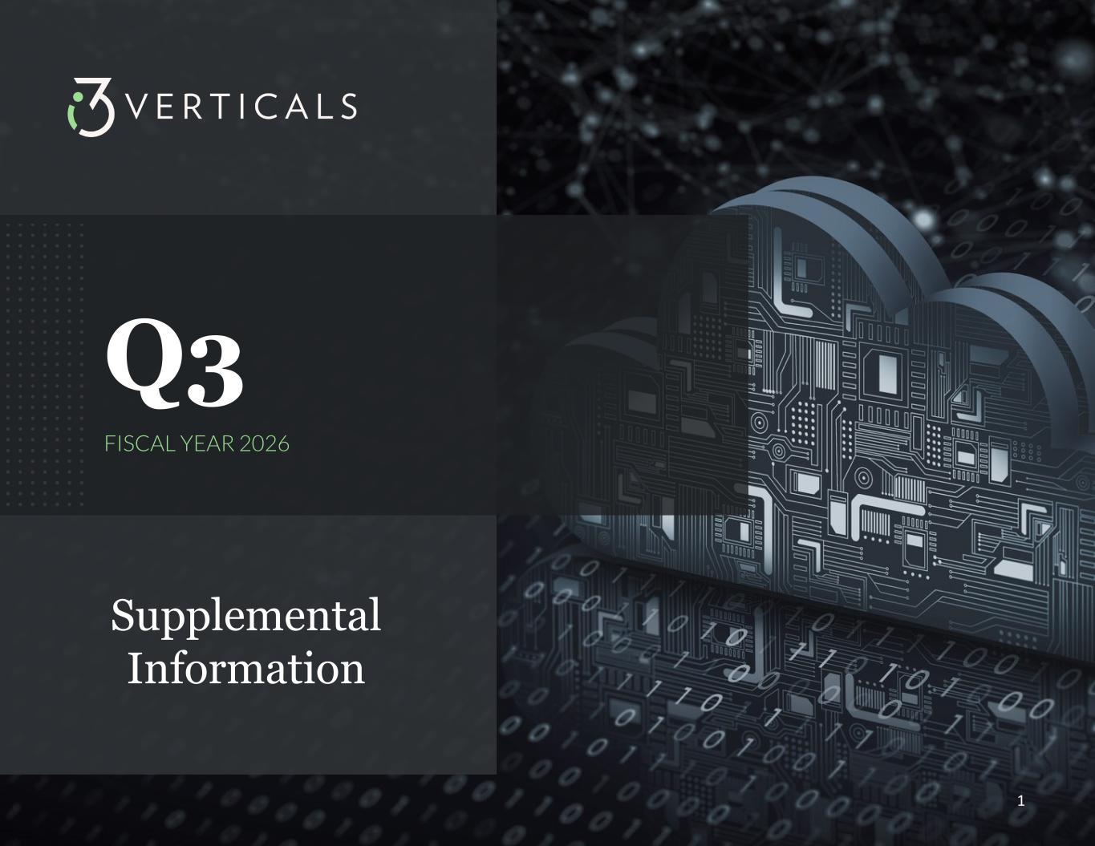
-END-
1 Supplemental Information Q3 FISCAL YEAR 2026

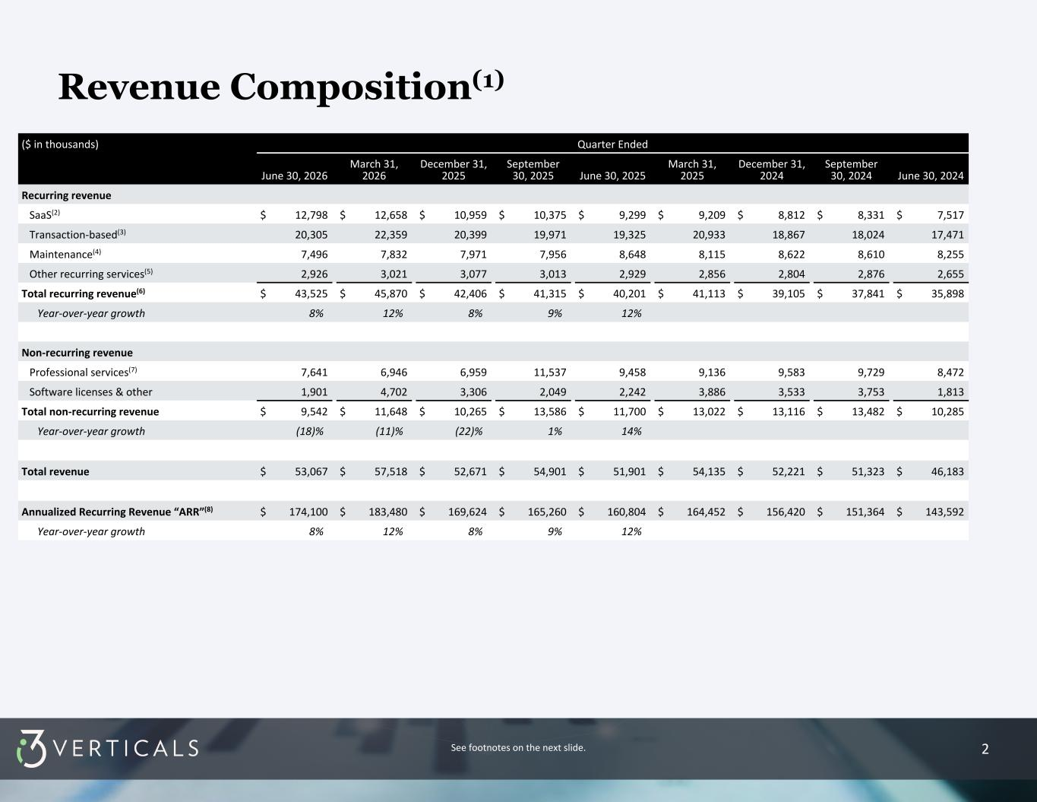
2 ($ in thousands) Quarter Ended June 30, 2026 March 31, 2026 December 31, 2025 September 30, 2025 June 30, 2025 March 31, 2025 December 31, 2024 September 30, 2024 June 30, 2024 Recurring revenue SaaS(2) $ 12,798 $ 12,658 $ 10,959 $ 10,375 $ 9,299 $ 9,209 $ 8,812 $ 8,331 $ 7,517 Transaction-based(3) 20,305 22,359 20,399 19,971 19,325 20,933 18,867 18,024 17,471 Maintenance(4) 7,496 7,832 7,971 7,956 8,648 8,115 8,622 8,610 8,255 Other recurring services(5) 2,926 3,021 3,077 3,013 2,929 2,856 2,804 2,876 2,655 Total recurring revenue(6) $ 43,525 $ 45,870 $ 42,406 $ 41,315 $ 40,201 $ 41,113 $ 39,105 $ 37,841 $ 35,898 Year-over-year growth 8 % 12 % 8 % 9 % 12 % Non-recurring revenue Professional services(7) 7,641 6,946 6,959 11,537 9,458 9,136 9,583 9,729 8,472 Software licenses & other 1,901 4,702 3,306 2,049 2,242 3,886 3,533 3,753 1,813 Total non-recurring revenue $ 9,542 $ 11,648 $ 10,265 $ 13,586 $ 11,700 $ 13,022 $ 13,116 $ 13,482 $ 10,285 Year-over-year growth (18) % (11) % (22) % 1 % 14 % Total revenue $ 53,067 $ 57,518 $ 52,671 $ 54,901 $ 51,901 $ 54,135 $ 52,221 $ 51,323 $ 46,183 Annualized Recurring Revenue “ARR”(8) $ 174,100 $ 183,480 $ 169,624 $ 165,260 $ 160,804 $ 164,452 $ 156,420 $ 151,364 $ 143,592 Year-over-year growth 8 % 12 % 8 % 9 % 12 % Revenue Composition(1) See footnotes on the next slide.

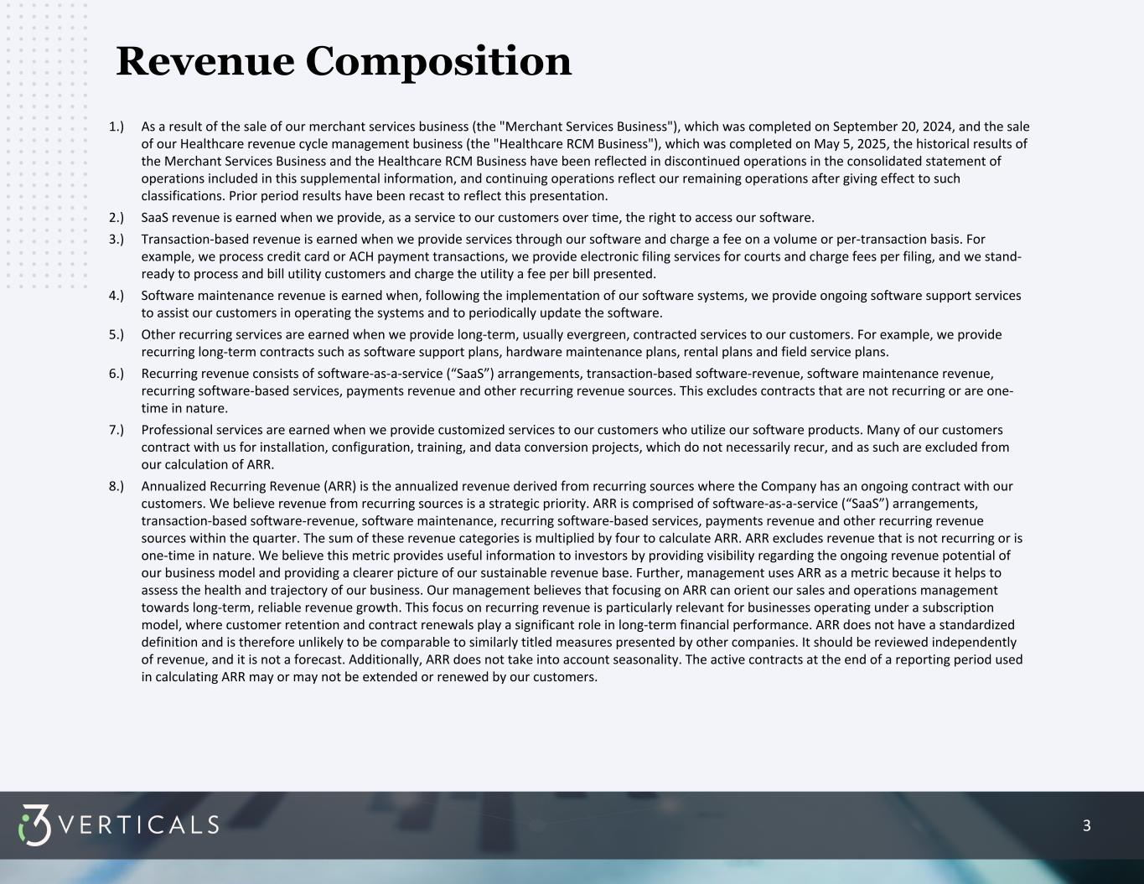
3 1.) As a result of the sale of our merchant services business (the "Merchant Services Business"), which was completed on September 20, 2024, and the sale of our Healthcare revenue cycle management business (the "Healthcare RCM Business"), which was completed on May 5, 2025, the historical results of the Merchant Services Business and the Healthcare RCM Business have been reflected in discontinued operations in the consolidated statement of operations included in this supplemental information, and continuing operations reflect our remaining operations after giving effect to such classifications. Prior period results have been recast to reflect this presentation. 2.) SaaS revenue is earned when we provide, as a service to our customers over time, the right to access our software. 3.) Transaction-based revenue is earned when we provide services through our software and charge a fee on a volume or per-transaction basis. For example, we process credit card or ACH payment transactions, we provide electronic filing services for courts and charge fees per filing, and we stand- ready to process and bill utility customers and charge the utility a fee per bill presented. 4.) Software maintenance revenue is earned when, following the implementation of our software systems, we provide ongoing software support services to assist our customers in operating the systems and to periodically update the software. 5.) Other recurring services are earned when we provide long-term, usually evergreen, contracted services to our customers. For example, we provide recurring long-term contracts such as software support plans, hardware maintenance plans, rental plans and field service plans. 6.) Recurring revenue consists of software-as-a-service (“SaaS”) arrangements, transaction-based software-revenue, software maintenance revenue, recurring software-based services, payments revenue and other recurring revenue sources. This excludes contracts that are not recurring or are one- time in nature. 7.) Professional services are earned when we provide customized services to our customers who utilize our software products. Many of our customers contract with us for installation, configuration, training, and data conversion projects, which do not necessarily recur, and as such are excluded from our calculation of ARR. 8.) Annualized Recurring Revenue (ARR) is the annualized revenue derived from recurring sources where the Company has an ongoing contract with our customers. We believe revenue from recurring sources is a strategic priority. ARR is comprised of software-as-a-service (“SaaS”) arrangements, transaction-based software-revenue, software maintenance, recurring software-based services, payments revenue and other recurring revenue sources within the quarter. The sum of these revenue categories is multiplied by four to calculate ARR. ARR excludes revenue that is not recurring or is one-time in nature. We believe this metric provides useful information to investors by providing visibility regarding the ongoing revenue potential of our business model and providing a clearer picture of our sustainable revenue base. Further, management uses ARR as a metric because it helps to assess the health and trajectory of our business. Our management believes that focusing on ARR can orient our sales and operations management towards long-term, reliable revenue growth. This focus on recurring revenue is particularly relevant for businesses operating under a subscription model, where customer retention and contract renewals play a significant role in long-term financial performance. ARR does not have a standardized definition and is therefore unlikely to be comparable to similarly titled measures presented by other companies. It should be reviewed independently of revenue, and it is not a forecast. Additionally, ARR does not take into account seasonality. The active contracts at the end of a reporting period used in calculating ARR may or may not be extended or renewed by our customers. Revenue Composition

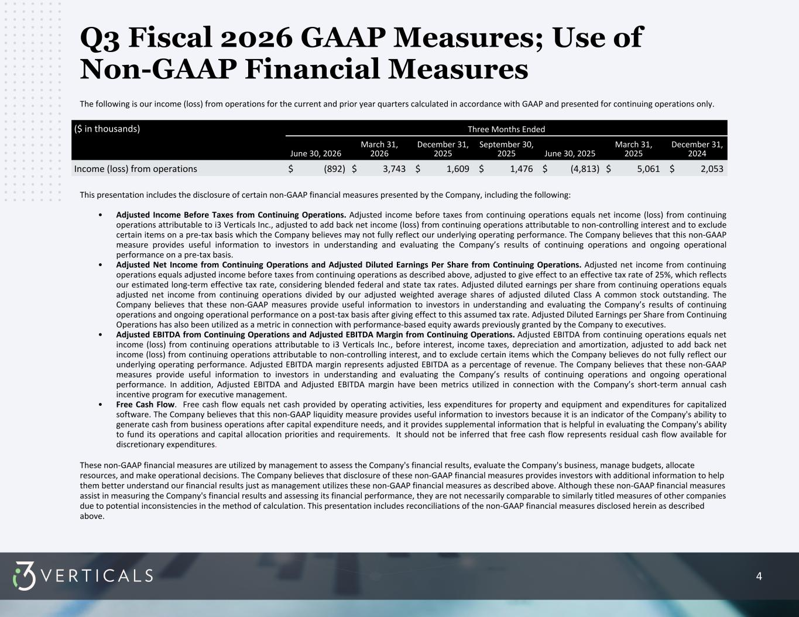
4 Q3 Fiscal 2026 GAAP Measures; Use of Non-GAAP Financial Measures The following is our income (loss) from operations for the current and prior year quarters calculated in accordance with GAAP and presented for continuing operations only. This presentation includes the disclosure of certain non-GAAP financial measures presented by the Company, including the following: • Adjusted Income Before Taxes from Continuing Operations. Adjusted income before taxes from continuing operations equals net income (loss) from continuing operations attributable to i3 Verticals Inc., adjusted to add back net income (loss) from continuing operations attributable to non-controlling interest and to exclude certain items on a pre-tax basis which the Company believes may not fully reflect our underlying operating performance. The Company believes that this non-GAAP measure provides useful information to investors in understanding and evaluating the Company’s results of continuing operations and ongoing operational performance on a pre-tax basis. • Adjusted Net Income from Continuing Operations and Adjusted Diluted Earnings Per Share from Continuing Operations. Adjusted net income from continuing operations equals adjusted income before taxes from continuing operations as described above, adjusted to give effect to an effective tax rate of 25%, which reflects our estimated long-term effective tax rate, considering blended federal and state tax rates. Adjusted diluted earnings per share from continuing operations equals adjusted net income from continuing operations divided by our adjusted weighted average shares of adjusted diluted Class A common stock outstanding. The Company believes that these non-GAAP measures provide useful information to investors in understanding and evaluating the Company’s results of continuing operations and ongoing operational performance on a post-tax basis after giving effect to this assumed tax rate. Adjusted Diluted Earnings per Share from Continuing Operations has also been utilized as a metric in connection with performance-based equity awards previously granted by the Company to executives. • Adjusted EBITDA from Continuing Operations and Adjusted EBITDA Margin from Continuing Operations. Adjusted EBITDA from continuing operations equals net income (loss) from continuing operations attributable to i3 Verticals Inc., before interest, income taxes, depreciation and amortization, adjusted to add back net income (loss) from continuing operations attributable to non-controlling interest, and to exclude certain items which the Company believes do not fully reflect our underlying operating performance. Adjusted EBITDA margin represents adjusted EBITDA as a percentage of revenue. The Company believes that these non-GAAP measures provide useful information to investors in understanding and evaluating the Company’s results of continuing operations and ongoing operational performance. In addition, Adjusted EBITDA and Adjusted EBITDA margin have been metrics utilized in connection with the Company’s short-term annual cash incentive program for executive management. • Free Cash Flow. Free cash flow equals net cash provided by operating activities, less expenditures for property and equipment and expenditures for capitalized software. The Company believes that this non-GAAP liquidity measure provides useful information to investors because it is an indicator of the Company's ability to generate cash from business operations after capital expenditure needs, and it provides supplemental information that is helpful in evaluating the Company's ability to fund its operations and capital allocation priorities and requirements. It should not be inferred that free cash flow represents residual cash flow available for discretionary expenditures. These non-GAAP financial measures are utilized by management to assess the Company's financial results, evaluate the Company's business, manage budgets, allocate resources, and make operational decisions. The Company believes that disclosure of these non-GAAP financial measures provides investors with additional information to help them better understand our financial results just as management utilizes these non-GAAP financial measures as described above. Although these non-GAAP financial measures assist in measuring the Company's financial results and assessing its financial performance, they are not necessarily comparable to similarly titled measures of other companies due to potential inconsistencies in the method of calculation. This presentation includes reconciliations of the non-GAAP financial measures disclosed herein as described above. ($ in thousands) Three Months Ended June 30, 2026 March 31, 2026 December 31, 2025 September 30, 2025 June 30, 2025 March 31, 2025 December 31, 2024 Income (loss) from operations $ (892) $ 3,743 $ 1,609 $ 1,476 $ (4,813) $ 5,061 $ 2,053

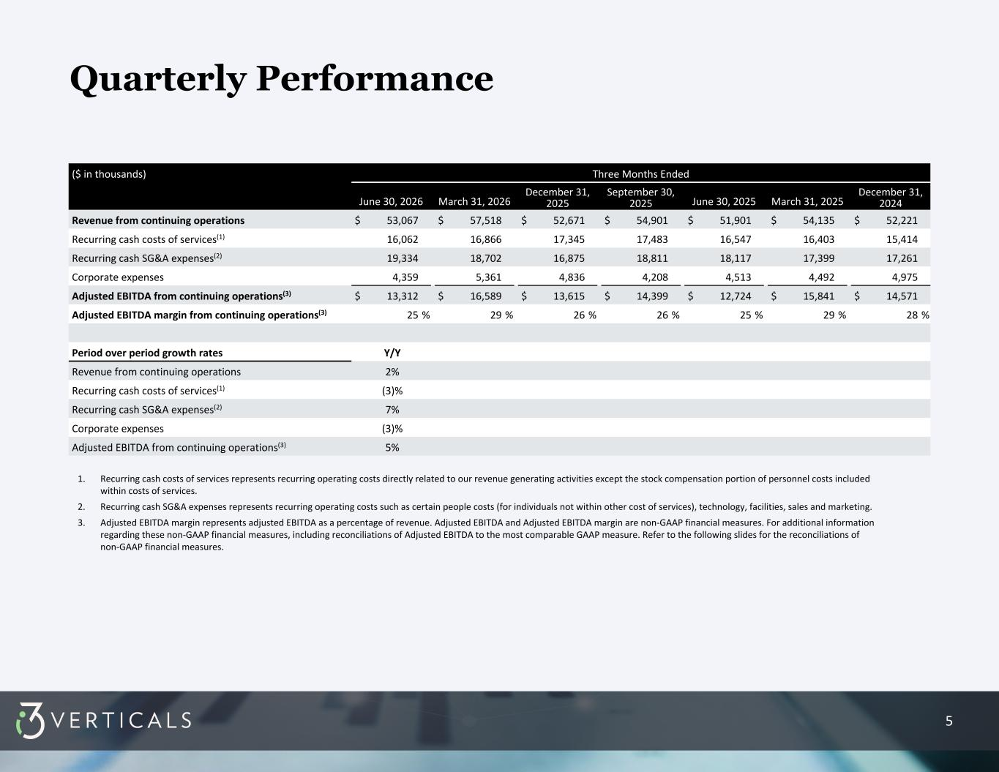
5 Quarterly Performance 1. Recurring cash costs of services represents recurring operating costs directly related to our revenue generating activities except the stock compensation portion of personnel costs included within costs of services. 2. Recurring cash SG&A expenses represents recurring operating costs such as certain people costs (for individuals not within other cost of services), technology, facilities, sales and marketing. 3. Adjusted EBITDA margin represents adjusted EBITDA as a percentage of revenue. Adjusted EBITDA and Adjusted EBITDA margin are non-GAAP financial measures. For additional information regarding these non-GAAP financial measures, including reconciliations of Adjusted EBITDA to the most comparable GAAP measure. Refer to the following slides for the reconciliations of non-GAAP financial measures. ($ in thousands) Three Months Ended June 30, 2026 March 31, 2026 December 31, 2025 September 30, 2025 June 30, 2025 March 31, 2025 December 31, 2024 Revenue from continuing operations $ 53,067 $ 57,518 $ 52,671 $ 54,901 $ 51,901 $ 54,135 $ 52,221 Recurring cash costs of services(1) 16,062 16,866 17,345 17,483 16,547 16,403 15,414 Recurring cash SG&A expenses(2) 19,334 18,702 16,875 18,811 18,117 17,399 17,261 Corporate expenses 4,359 5,361 4,836 4,208 4,513 4,492 4,975 Adjusted EBITDA from continuing operations(3) $ 13,312 $ 16,589 $ 13,615 $ 14,399 $ 12,724 $ 15,841 $ 14,571 Adjusted EBITDA margin from continuing operations(3) 25 % 29 % 26 % 26 % 25 % 29 % 28 % Period over period growth rates Y/Y Revenue from continuing operations 2% Recurring cash costs of services(1) (3)% Recurring cash SG&A expenses(2) 7% Corporate expenses (3)% Adjusted EBITDA from continuing operations(3) 5%

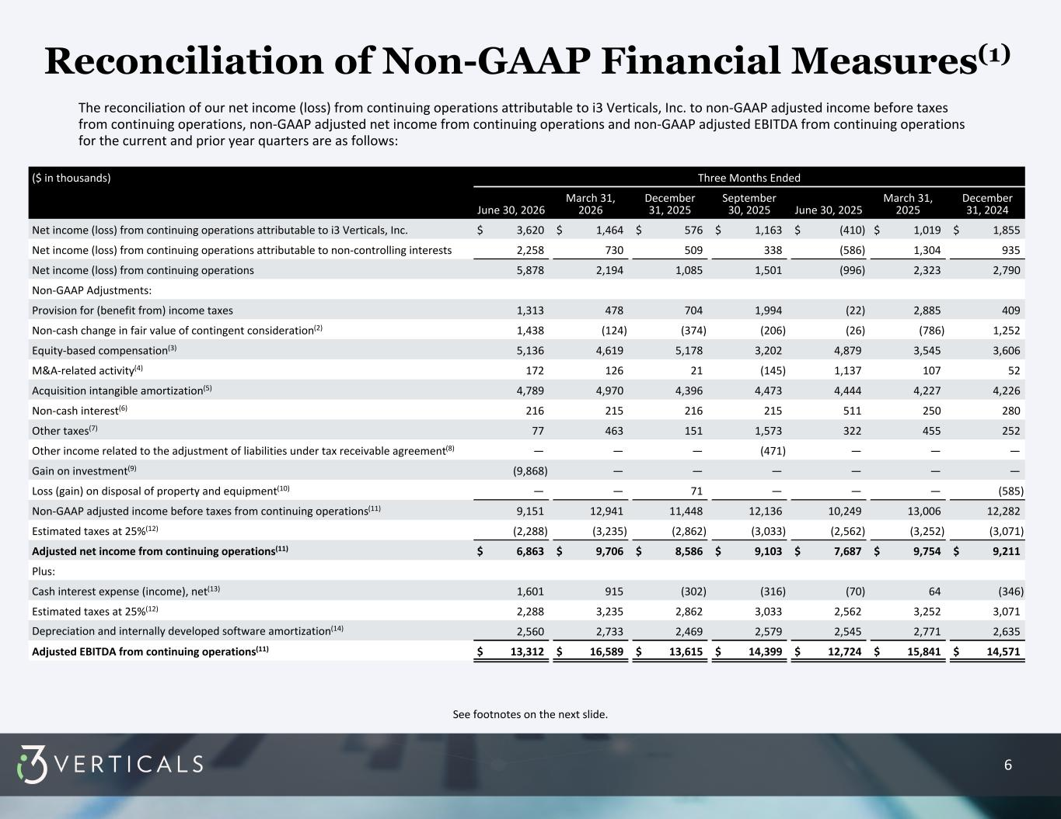
6 Reconciliation of Non-GAAP Financial Measures(1) The reconciliation of our net income (loss) from continuing operations attributable to i3 Verticals, Inc. to non-GAAP adjusted income before taxes from continuing operations, non-GAAP adjusted net income from continuing operations and non-GAAP adjusted EBITDA from continuing operations for the current and prior year quarters are as follows: ($ in thousands) Three Months Ended June 30, 2026 March 31, 2026 December 31, 2025 September 30, 2025 June 30, 2025 March 31, 2025 December 31, 2024 Net income (loss) from continuing operations attributable to i3 Verticals, Inc. $ 3,620 $ 1,464 $ 576 $ 1,163 $ (410) $ 1,019 $ 1,855 Net income (loss) from continuing operations attributable to non-controlling interests 2,258 730 509 338 (586) 1,304 935 Net income (loss) from continuing operations 5,878 2,194 1,085 1,501 (996) 2,323 2,790 Non-GAAP Adjustments: Provision for (benefit from) income taxes 1,313 478 704 1,994 (22) 2,885 409 Non-cash change in fair value of contingent consideration(2) 1,438 (124) (374) (206) (26) (786) 1,252 Equity-based compensation(3) 5,136 4,619 5,178 3,202 4,879 3,545 3,606 M&A-related activity(4) 172 126 21 (145) 1,137 107 52 Acquisition intangible amortization(5) 4,789 4,970 4,396 4,473 4,444 4,227 4,226 Non-cash interest(6) 216 215 216 215 511 250 280 Other taxes(7) 77 463 151 1,573 322 455 252 Other income related to the adjustment of liabilities under tax receivable agreement(8) — — — (471) — — — Gain on investment(9) (9,868) — — — — — — Loss (gain) on disposal of property and equipment(10) — — 71 — — — (585) Non-GAAP adjusted income before taxes from continuing operations(11) 9,151 12,941 11,448 12,136 10,249 13,006 12,282 Estimated taxes at 25%(12) (2,288) (3,235) (2,862) (3,033) (2,562) (3,252) (3,071) Adjusted net income from continuing operations(11) $ 6,863 $ 9,706 $ 8,586 $ 9,103 $ 7,687 $ 9,754 $ 9,211 Plus: Cash interest expense (income), net(13) 1,601 915 (302) (316) (70) 64 (346) Estimated taxes at 25%(12) 2,288 3,235 2,862 3,033 2,562 3,252 3,071 Depreciation and internally developed software amortization(14) 2,560 2,733 2,469 2,579 2,545 2,771 2,635 Adjusted EBITDA from continuing operations(11) $ 13,312 $ 16,589 $ 13,615 $ 14,399 $ 12,724 $ 15,841 $ 14,571 See footnotes on the next slide.

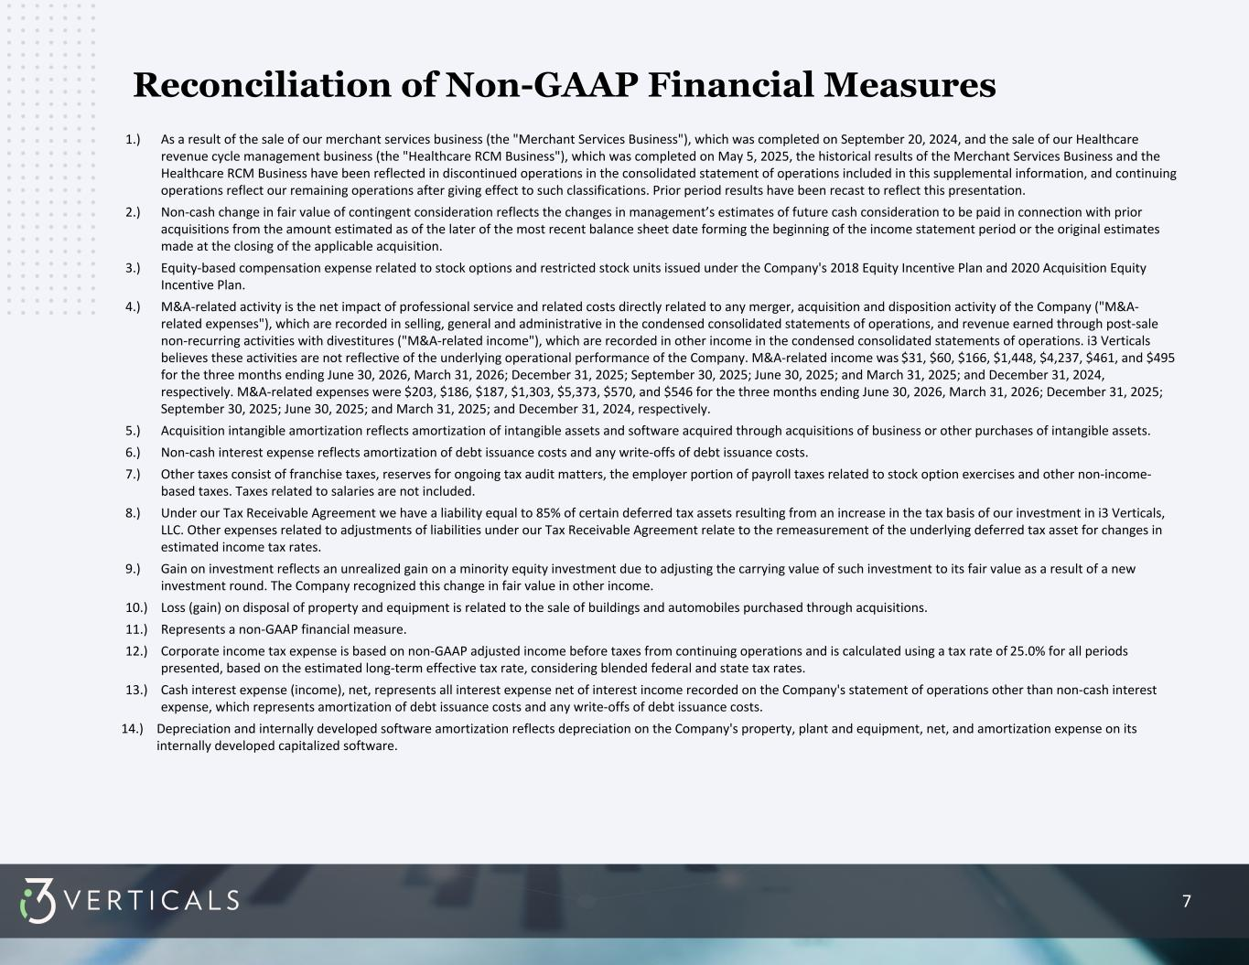
7 1.) As a result of the sale of our merchant services business (the "Merchant Services Business"), which was completed on September 20, 2024, and the sale of our Healthcare revenue cycle management business (the "Healthcare RCM Business"), which was completed on May 5, 2025, the historical results of the Merchant Services Business and the Healthcare RCM Business have been reflected in discontinued operations in the consolidated statement of operations included in this supplemental information, and continuing operations reflect our remaining operations after giving effect to such classifications. Prior period results have been recast to reflect this presentation. 2.) Non-cash change in fair value of contingent consideration reflects the changes in management’s estimates of future cash consideration to be paid in connection with prior acquisitions from the amount estimated as of the later of the most recent balance sheet date forming the beginning of the income statement period or the original estimates made at the closing of the applicable acquisition. 3.) Equity-based compensation expense related to stock options and restricted stock units issued under the Company's 2018 Equity Incentive Plan and 2020 Acquisition Equity Incentive Plan. 4.) M&A-related activity is the net impact of professional service and related costs directly related to any merger, acquisition and disposition activity of the Company ("M&A- related expenses"), which are recorded in selling, general and administrative in the condensed consolidated statements of operations, and revenue earned through post-sale non-recurring activities with divestitures ("M&A-related income"), which are recorded in other income in the condensed consolidated statements of operations. i3 Verticals believes these activities are not reflective of the underlying operational performance of the Company. M&A-related income was $31, $60, $166, $1,448, $4,237, $461, and $495 for the three months ending June 30, 2026, March 31, 2026; December 31, 2025; September 30, 2025; June 30, 2025; and March 31, 2025; and December 31, 2024, respectively. M&A-related expenses were $203, $186, $187, $1,303, $5,373, $570, and $546 for the three months ending June 30, 2026, March 31, 2026; December 31, 2025; September 30, 2025; June 30, 2025; and March 31, 2025; and December 31, 2024, respectively. 5.) Acquisition intangible amortization reflects amortization of intangible assets and software acquired through acquisitions of business or other purchases of intangible assets. 6.) Non-cash interest expense reflects amortization of debt issuance costs and any write-offs of debt issuance costs. 7.) Other taxes consist of franchise taxes, reserves for ongoing tax audit matters, the employer portion of payroll taxes related to stock option exercises and other non-income- based taxes. Taxes related to salaries are not included. 8.) Under our Tax Receivable Agreement we have a liability equal to 85% of certain deferred tax assets resulting from an increase in the tax basis of our investment in i3 Verticals, LLC. Other expenses related to adjustments of liabilities under our Tax Receivable Agreement relate to the remeasurement of the underlying deferred tax asset for changes in estimated income tax rates. 9.) Gain on investment reflects an unrealized gain on a minority equity investment due to adjusting the carrying value of such investment to its fair value as a result of a new investment round. The Company recognized this change in fair value in other income. 10.) Loss (gain) on disposal of property and equipment is related to the sale of buildings and automobiles purchased through acquisitions. 11.) Represents a non-GAAP financial measure. 12.) Corporate income tax expense is based on non-GAAP adjusted income before taxes from continuing operations and is calculated using a tax rate of 25.0% for all periods presented, based on the estimated long-term effective tax rate, considering blended federal and state tax rates. 13.) Cash interest expense (income), net, represents all interest expense net of interest income recorded on the Company's statement of operations other than non-cash interest expense, which represents amortization of debt issuance costs and any write-offs of debt issuance costs. 14.) Depreciation and internally developed software amortization reflects depreciation on the Company's property, plant and equipment, net, and amortization expense on its internally developed capitalized software. Reconciliation of Non-GAAP Financial Measures

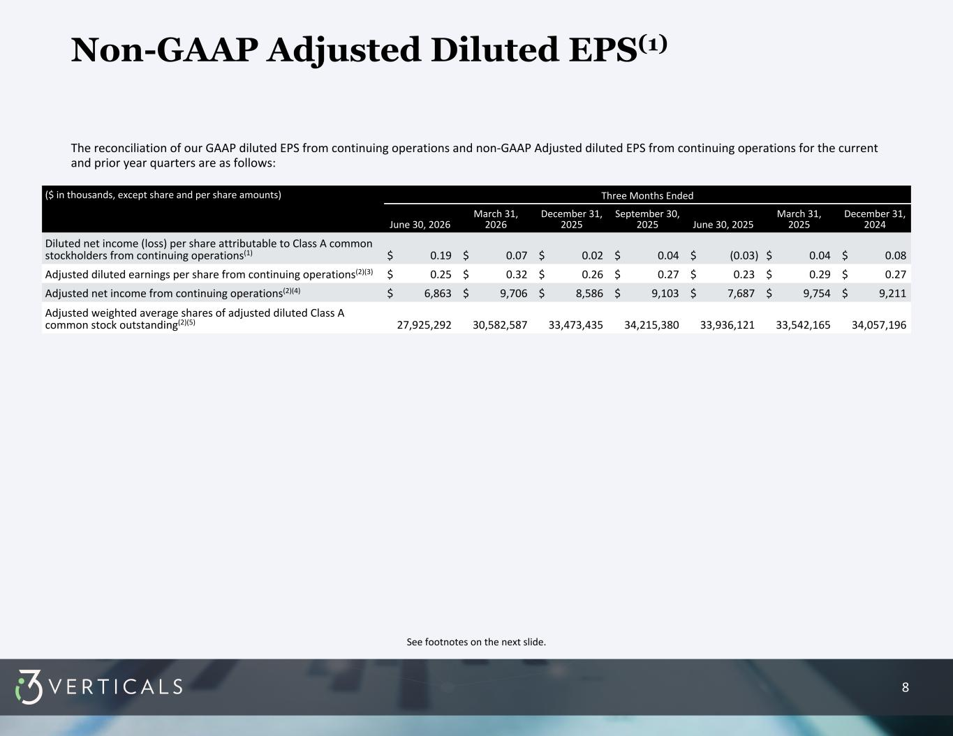
8 See footnotes on the next slide. Non-GAAP Adjusted Diluted EPS(1) The reconciliation of our GAAP diluted EPS from continuing operations and non-GAAP Adjusted diluted EPS from continuing operations for the current and prior year quarters are as follows: ($ in thousands, except share and per share amounts) Three Months Ended June 30, 2026 March 31, 2026 December 31, 2025 September 30, 2025 June 30, 2025 March 31, 2025 December 31, 2024 Diluted net income (loss) per share attributable to Class A common stockholders from continuing operations(1) $ 0.19 $ 0.07 $ 0.02 $ 0.04 $ (0.03) $ 0.04 $ 0.08 Adjusted diluted earnings per share from continuing operations(2)(3) $ 0.25 $ 0.32 $ 0.26 $ 0.27 $ 0.23 $ 0.29 $ 0.27 Adjusted net income from continuing operations(2)(4) $ 6,863 $ 9,706 $ 8,586 $ 9,103 $ 7,687 $ 9,754 $ 9,211 Adjusted weighted average shares of adjusted diluted Class A common stock outstanding(2)(5) 27,925,292 30,582,587 33,473,435 34,215,380 33,936,121 33,542,165 34,057,196

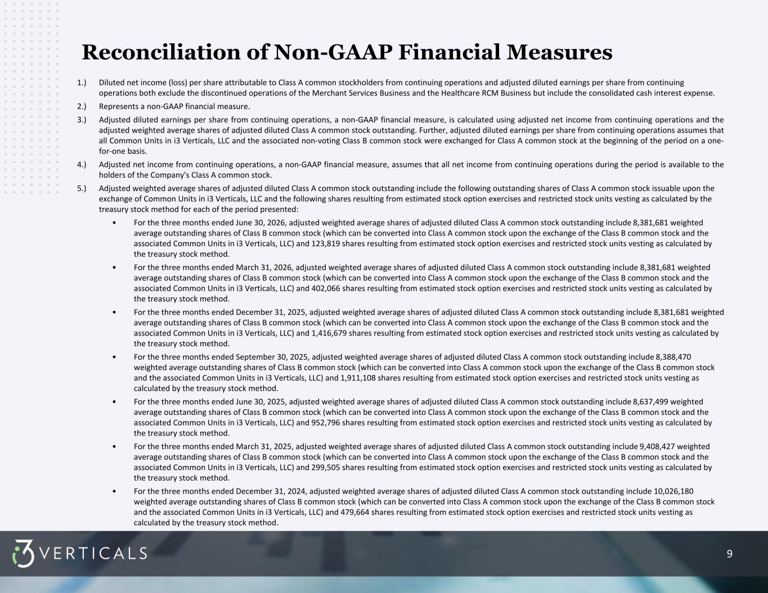
9 1.) Diluted net income (loss) per share attributable to Class A common stockholders from continuing operations and adjusted diluted earnings per share from continuing operations both exclude the discontinued operations of the Merchant Services Business and the Healthcare RCM Business but include the consolidated cash interest expense. 2.) Represents a non-GAAP financial measure. 3.) Adjusted diluted earnings per share from continuing operations, a non-GAAP financial measure, is calculated using adjusted net income from continuing operations and the adjusted weighted average shares of adjusted diluted Class A common stock outstanding. Further, adjusted diluted earnings per share from continuing operations assumes that all Common Units in i3 Verticals, LLC and the associated non-voting Class B common stock were exchanged for Class A common stock at the beginning of the period on a one- for-one basis. 4.) Adjusted net income from continuing operations, a non-GAAP financial measure, assumes that all net income from continuing operations during the period is available to the holders of the Company's Class A common stock. 5.) Adjusted weighted average shares of adjusted diluted Class A common stock outstanding include the following outstanding shares of Class A common stock issuable upon the exchange of Common Units in i3 Verticals, LLC and the following shares resulting from estimated stock option exercises and restricted stock units vesting as calculated by the treasury stock method for each of the period presented: • For the three months ended June 30, 2026, adjusted weighted average shares of adjusted diluted Class A common stock outstanding include 8,381,681 weighted average outstanding shares of Class B common stock (which can be converted into Class A common stock upon the exchange of the Class B common stock and the associated Common Units in i3 Verticals, LLC) and 123,819 shares resulting from estimated stock option exercises and restricted stock units vesting as calculated by the treasury stock method. • For the three months ended March 31, 2026, adjusted weighted average shares of adjusted diluted Class A common stock outstanding include 8,381,681 weighted average outstanding shares of Class B common stock (which can be converted into Class A common stock upon the exchange of the Class B common stock and the associated Common Units in i3 Verticals, LLC) and 402,066 shares resulting from estimated stock option exercises and restricted stock units vesting as calculated by the treasury stock method. • For the three months ended December 31, 2025, adjusted weighted average shares of adjusted diluted Class A common stock outstanding include 8,381,681 weighted average outstanding shares of Class B common stock (which can be converted into Class A common stock upon the exchange of the Class B common stock and the associated Common Units in i3 Verticals, LLC) and 1,416,679 shares resulting from estimated stock option exercises and restricted stock units vesting as calculated by the treasury stock method. • For the three months ended September 30, 2025, adjusted weighted average shares of adjusted diluted Class A common stock outstanding include 8,388,470 weighted average outstanding shares of Class B common stock (which can be converted into Class A common stock upon the exchange of the Class B common stock and the associated Common Units in i3 Verticals, LLC) and 1,911,108 shares resulting from estimated stock option exercises and restricted stock units vesting as calculated by the treasury stock method. • For the three months ended June 30, 2025, adjusted weighted average shares of adjusted diluted Class A common stock outstanding include 8,637,499 weighted average outstanding shares of Class B common stock (which can be converted into Class A common stock upon the exchange of the Class B common stock and the associated Common Units in i3 Verticals, LLC) and 952,796 shares resulting from estimated stock option exercises and restricted stock units vesting as calculated by the treasury stock method. • For the three months ended March 31, 2025, adjusted weighted average shares of adjusted diluted Class A common stock outstanding include 9,408,427 weighted average outstanding shares of Class B common stock (which can be converted into Class A common stock upon the exchange of the Class B common stock and the associated Common Units in i3 Verticals, LLC) and 299,505 shares resulting from estimated stock option exercises and restricted stock units vesting as calculated by the treasury stock method. • For the three months ended December 31, 2024, adjusted weighted average shares of adjusted diluted Class A common stock outstanding include 10,026,180 weighted average outstanding shares of Class B common stock (which can be converted into Class A common stock upon the exchange of the Class B common stock and the associated Common Units in i3 Verticals, LLC) and 479,664 shares resulting from estimated stock option exercises and restricted stock units vesting as calculated by the treasury stock method. Reconciliation of Non-GAAP Financial Measures

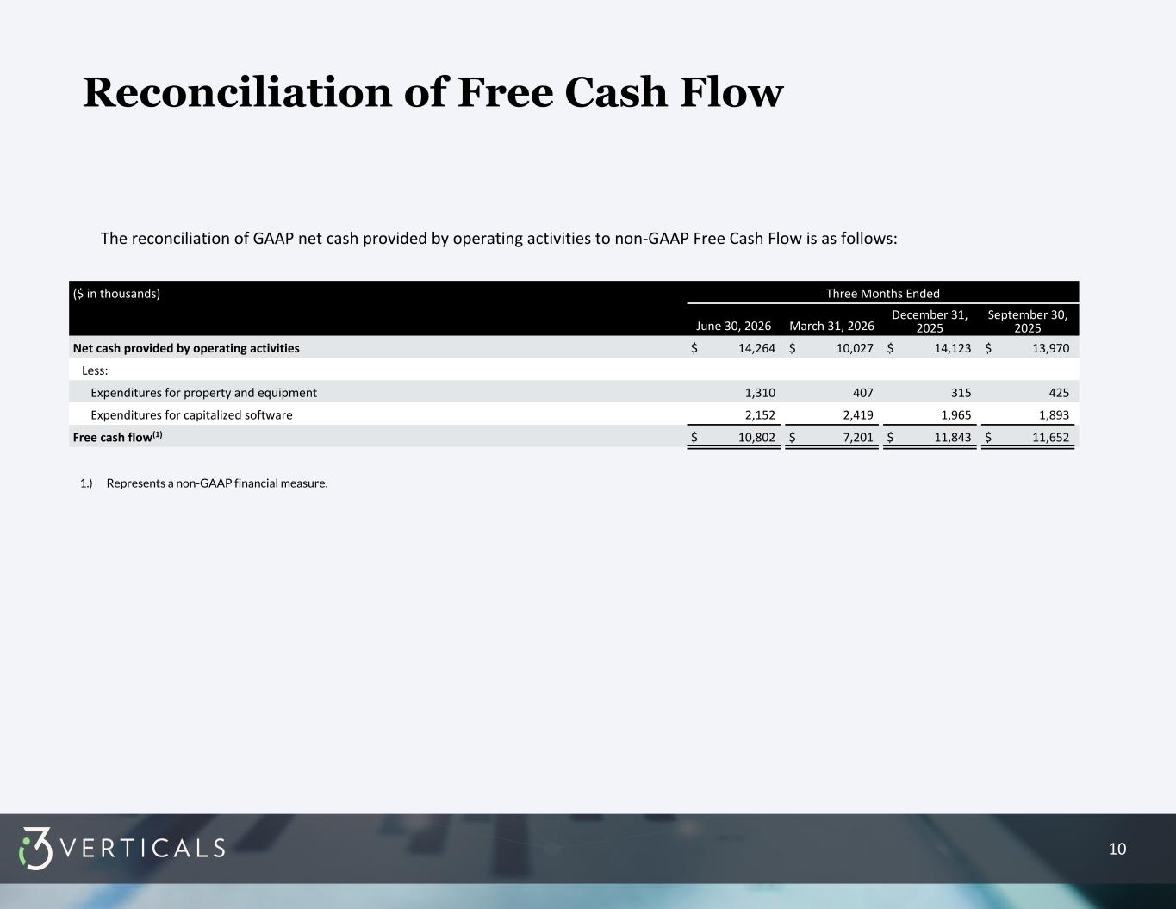
10 Reconciliation of Free Cash Flow The reconciliation of GAAP net cash provided by operating activities to non-GAAP Free Cash Flow is as follows: ($ in thousands) Three Months Ended June 30, 2026 March 31, 2026 December 31, 2025 September 30, 2025 Net cash provided by operating activities $ 14,264 $ 10,027 $ 14,123 $ 13,970 Less: Expenditures for property and equipment 1,310 407 315 425 Expenditures for capitalized software 2,152 2,419 1,965 1,893 Free cash flow(1) $ 10,802 $ 7,201 $ 11,843 $ 11,652 1.) Represents a non-GAAP financial measure.

